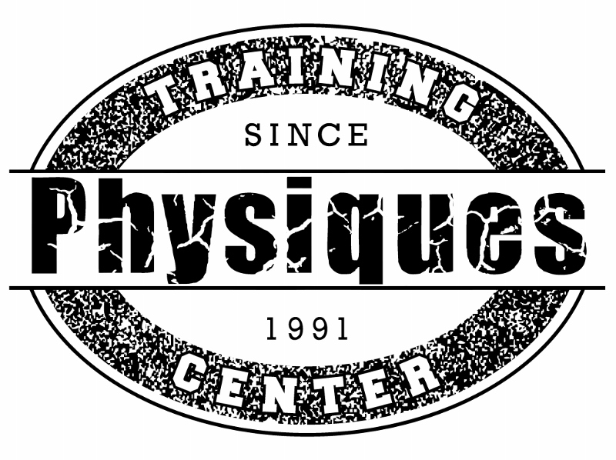

Physiques Training Center Health Coaching

Our training center is so excited to present Health Coaching to our members and clients. Physiques is the only training center with a full staff including Physician, RN, Registered Dietitian and Certified Trainers. We strive to empower and educate our clients.
Health Coaching helps our clients with Habit change, Results, and healthy lifestyle.

WHAT IS INCLUDED:
*Full nutrition assessment
*Small group strength training
*Injury prevention and recognition
*Supplement Solution
*Weekly body compositions and water evaluations
*Individualized exercise prescription from an Exercise Physiologist and RN
*Recommended flexibility training
*Objective setting
*Weekly exercise revisions

A Physiques Health Coach plays and important role in the client’s success and sustainability

